Showcase of my Skills portfolio

Reflection on career Aspirations
My name is Einartas Karvelis, and I am a cyber security student at Nottingham Trent university. I have been interested in pursuing a career in either systems analysis or data analysis, with this section I am reflecting on my career aspirations and planning my next steps.
System analysis and data analysis, as I have researched are both important roles in the field of IT (Information Technology). As for systems-analysts, they are responsible for analysing computer-systems and procedures to improve the efficiency and productivity, while for data-analysts use statistical analysis and modelling to interpret complex data sets. For both roles require strong technical skills, problem-solving capabilities, with the attention to detail. There is still a possibility that I would find another role more suited to my skillset which I both enjoy and is able to develop to a broader range of capabilities.
I am intrigued to systems analysis as I enjoy working with complex systems and being able to find ways to optimize their performance. I have already gained experience in this area through my coursework and practical application to my research at home where I was able to improve my analysis and technicality to different systems. As with data analysis because I believe that data-driven decision making is becoming increasingly important in many industries.
These areas are competitive fields, and I anticipate that one of the biggest challenges will be gaining the necessary experience to stand out for the job market. To be able to overcome this, I plan to continue building my skills through coursework and research, and I will also seek out networking opportunities to make connections in the industry.
Analysis & Evidence of own skills
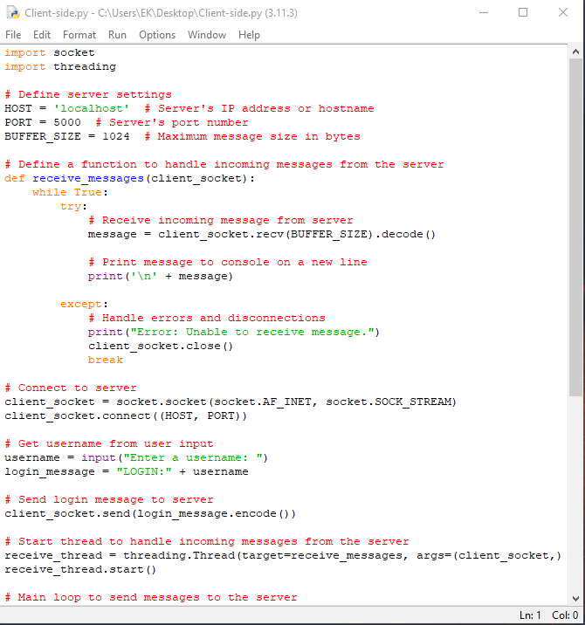
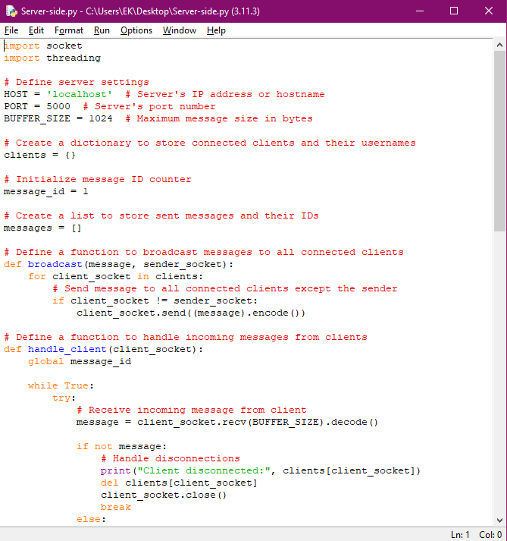
I have been developing my python knowledge throughout university by attending labs and completing coursework set. I was first introduced to python in college where I was able to see how the programs looked like when they were developed with this specific language but was not my focus until university. My knowledge expanded in python with the addition of network-based libraries. The development of my network-based chat server where a server was run, and multiple other users were able to connect to that specific server and be able to communicate with one another, with this I was able to expand an area of python I have no explore before :
I was introduced to systems such as laptops and desktops throughout my childhood and immediately gained an interest in gaming, but however as I had a subpar system, I have had to watch various YouTube videos that would allow me to change in game configuration files, which resulted in my increased knowledge for how to access the files and which of them to appropriately configure so that the system is running games as efficiently as it can depending on the systems components, I started to research and analyse the components that would be best for price and performance.
I was able to integrate this knowledge into my course in university as I had a higher understanding of file management. This being illustrated by, with visual studio, I had the skills to manage and analyse the files I had to create for my coursework, allowing me to more efficiently fix problems for my coursework. For example, there was a misnamed directory in my visual studio, making my project unable to run.
With my free time in university, I took the opportunity to learn and understand the operation of a programming language called SQL, I was able to research and install a virtual machine on my desktop for the access of the Linux operating system. I was able to gain a higher understanding of a different OS and a programming language that is used to manage information that is stored in databases and has the data structured in tables.
Knowledge & Skill Development and Goals
Over the duration of the course, I became aware that there are various approaches to earning CPD points. Even though I did not make use of all the possibilities that I desired, I am convinced that my participation level was sufficient to fulfil my requirements.
With online workshops I have been able to attend an hour of a tutorial on creating and developing a GitHub repository where they shown students on how to install a desktop version of GitHub where you are able to save files such as coursework to then be displayed for other users or potential employers.
Another opportunity I was able to obtain was a 3-hour event where I viewed other second year students on how their experience was in industry and what kind of skills, they can give you and the opportunities you can gain after doing your placement year. Some of them were illustrating on how they were able to work from home and come into work, giving the advantages and disadvantages of this. As a result of this I was able to get a clearer view on how the application and process of the industry year was.
YouTube has the greatest number of sources that I can gain knowledge from, as most of my current and developing skills have been introduced through this website. It offers a wide range of tutorials, guides, and how-to videos on various IT-related topics. It was very easy for me to type in ‘python tutorials’ on YouTube and found myself a variety of video I can learn from.
I was able to develop my mathematical-computer skills by doing a variety of problems that tested my knowledge and gave me an idea on what I needed more improvement on and what my strengths were:
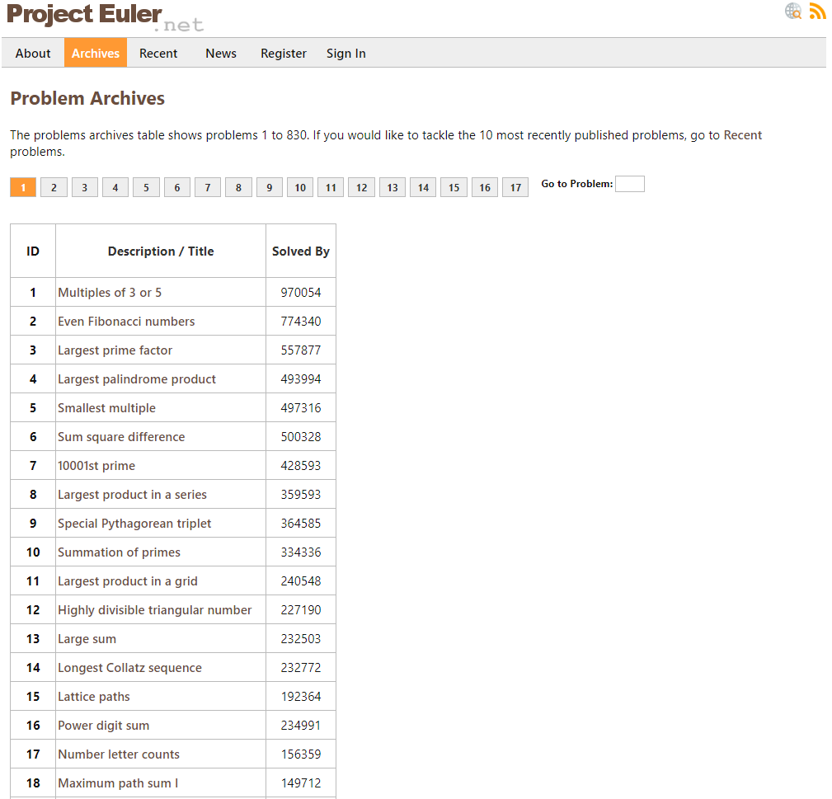
Reflection on professional conduct
During this term, my current approach with labs and lectures, my attendance can be improved by sorting out a schedule for myself so I can be more efficient in my day, and I am able to sort out which activities are more valuable than others. I would be able to find more activities and workshops to attend so I will be able to give myself more opportunities. Such as DevSoc events and researching more opportunities from my module and give me a clearer goal for after my graduation and my placement year.

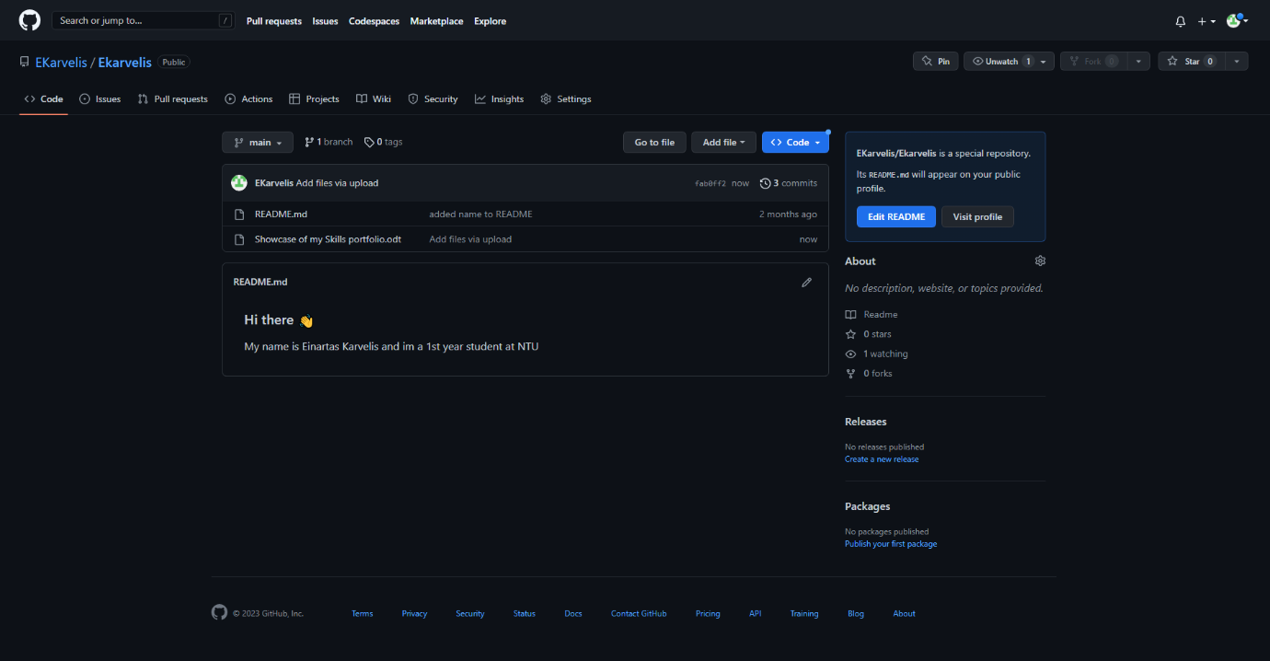
Screenshot of GitHub repository

